SOURCE WEBSITES:

1. <https://allfishinggears.com/best-electric-fishing-reels/> (MOST OF THIS REVIEW)

Edits were mostly adding pics, formatting text to individual pgs, price look up and notations…

1. OTHER SITE RESOURCES

https://www.deepdropper.com/collections/banax-electric-reels

Planning to buy an electric fishing reel? Here is a complete electric fishing reel buyers guide. Check it out to make an informed purchase!

Fishing is a therapeutic experience. It is a fun task that allows you to spend some quality time in the lap of nature. It doesn’t matter if you’re a pro fisherman or a new fishing enthusiast, you will be equally excited for your fishing adventure every time. While it is truly a stress-busting task that everyone enjoys, it can be a tiresome job without the right gear. To avoid any hassle and to prevent yourself from exhausting, you should be well-equipped with proper fishing tools and gear.

Talking about the most important fishing gear, a reel tops the list. It has the ability to make your fishing experience boring to super fun. But when it comes to buying the right fishing reel, you can easily get confused after finding tons of varieties. To help you save some time and money, here is a **complete electric fishing reel buyers guide** for you!

Table of Contents [[show](https://allfishinggears.com/best-electric-fishing-reels/)]

## Quick Summary – Best Electric Fishing Reels

* Best Overall: [Daiwa TANACOM](https://bassproshops.vzck.net/b3jVk6)
* Best Value for Money: [Banax Kaigen 7000CP](https://www.amazon.com/dp/B079RY89SY?tag=allfishing086-20&linkCode=ogi&th=1&psc=1)
* Best Heavy Duty: [Shimano Beastmaster](https://www.amazon.com/dp/B08CY4DHQT?tag=allfishing086-20&linkCode=ogi&th=1&psc=1)

[Daiwa TANACOM1000 Dendoh Fishing Reel, 30-40 lb, Black](https://www.amazon.com/dp/B00GT3F3SG?tag=allfishing086-20&linkCode=ogi&th=1&psc=1) – **HIGHLIGHT FEATURES**

* New LCD display reads out in English for easier programming
* Oversize line guide aperture to clear large knots and kite swivels
* Automatic Stop and jigging features

## ****Electric Fishing Reels Buyers Guide****

### ****Why Should You Buy An Electric Fishing Reel?****

**An electric fishing reel is one of the most useful tools, especially for deep drop fishing.** Although it has the same components as handle, bearings, spool, gears, it has some additional functionalities as well. You can say that it’s an advanced fishing reel. These extra features include a convenient LCD monitor, power cord, extra battery, operative buttons and some others. All these features make these fishing reels very unique and useful.

### ****What Are The Benefits of Using Electric Fishing Reel?****

Electric fishing reels are no less than a boon to fishing enthusiasts who love deep drop fishing. They make fishing less tiresome and more fun with their advanced features.

Their exceptional features and abilities take most of the load off the fisherman which makes them the highly sought-after tool. They come with advanced features such as LCD displays, detectors, sensors, indicators that make the fishing a cakewalk. These features help in setting the accurate aims and monitoring the line towards the fish.

Electric fishing reels also help the fisherman to lift the huge catches from the deep waters effortlessly. Let’s now discuss the electric fishing reel buyers guide!

When you’re looking for the **best electric fishing reel**, there are numerous factors that you should consider to make the right choice. Here are some of the most important factors to look for in an electric reel :

### Speed of Retrieval

Speed of retrieval is the first and the most important factor to look for. So, begin by checking the retrieval speed of the reel. This will give you an idea of how fast the reel brings the line in. Keep in mind, the faster the better. However, if you’re aiming a fighter, give more importance to torque than the reel. The ideal way is to look for a reel that offers a perfect balance between the speed and the torque.

### The Line Capacity

Generally, fishermen use braided lines for deep drop fishing and those too in enough quantity.

Put the reel aside, you’ll also need more lines for casting. The heaviest line weighs around 200 pounds whereas the lightest braided lines weigh around 80 to 100 lbs. The length and weight of the line depends upon the type of fish you’re going to aim and the location where you’re fishing. So, select the line and reel accordingly.

### Maximum Drag System

Drag is often the most overlooked feature of a reel but don’t do this. This is extremely important if you’re using an electric fishing line. **If the drag is too loose, fish will spit the hook**. Similarly, if the drag is too tight, your line could break. The best option is to look for a drag that is between 40 to 80 pounds. If it’s lower than 40 lbs or higher than 80lbs, the electric fishing reel is of no use.

### Gear System

Gear system is another crucial component of an electric fishing reel. Opt for a reel that features a separate gear system. You will find some reels with only one gear and retrieval speed, avoid them as they are not that efficient. Go for the reel that has a different gear and retrieval speed so that you can take control of it when required.

### Line Counter

Line Counter is a very helpful feature for deep-sea fishing. So, don’t ignore it if you really want to enjoy fishing. Another reason to think about the line capacity is, you never know the actual depth of water you’re fishing in. But with this feature, you can get a fair idea about how much you need to gauge to bring the catch to the surface.

### Power Supply

The majority of fishing reels work on 12V power supply and different amps. You can either use your own power source or use the power supply of the boat. Make sure to charge the battery to 100% before going fishing or else you’ll have to do a lot of hard work.

### Deep Sea Fishing

Electric reels are often used when fishing the deep sea. I have seen people catching sailfish from 2000 feet deep using an electric reel.

There are plenty of deep trenches or valleys that hold all manner of weird and interesting fish. Instead of wearing out your shoulder by retrieving hundreds of feet of line just a replace a bait, let electricity do it for you.

### Electric Reels for Handicapped People

One of the **primary benefits of electric fishing reels is that it allows people with handicaps to experience the beauty of fishing**. This could be people with physical disabilities or who have experienced strokes. Electric reels take away the grueling physical labor of retrieving a big fish.

## 10 Best Electric Fishing Reels & A Few Other Additions

## C:\Users\kindp\Desktop\ELECTRIC REEL FILES\PICS\Daiwa Tanacom1000 Dendoh.jpg

**1. Daiwa Tanacom** - [Daiwa TANACOM1000 Dendoh Fishing Reel, 30-40 lb, Black](https://www.amazon.com/dp/B00GT3F3SG?tag=allfishing086-20&linkCode=ogi&th=1&psc=1)

**Performance** – 5/5

**Durability** – 5/5

**Value for Money** – 4/5

**Overall Score** – 5/5

* New LCD display reads out in English for easier programming
* Oversize line guide aperture to clear large knots and kite swivels
* Automatic Stop and jigging features

Daiwa is an extremely popular reel manufacturer and the TANACOM 1000 is one of the best electric reels on the market.

Some of the features include an automated stop at particular depths and jigging features to help you attract that trophy fish. With a gear ratio of 2.3:1 this reel has some serious torque.

It also has a line counter so you can see what depth you are fishing at which can be used in combination with fish finders.

It also has an oversized line guide so that you can pass through large knots and swivels which is useful for big game fishing, kite fishing, or [drone fishing](https://allfishinggears.com/drone-fishing-tips/).

#### Pros

* Line counter shows you your bait depth
* Oversized line guides are suitable for big game tackle
* Serious torque

#### Cons

* Expensive but is still value for money

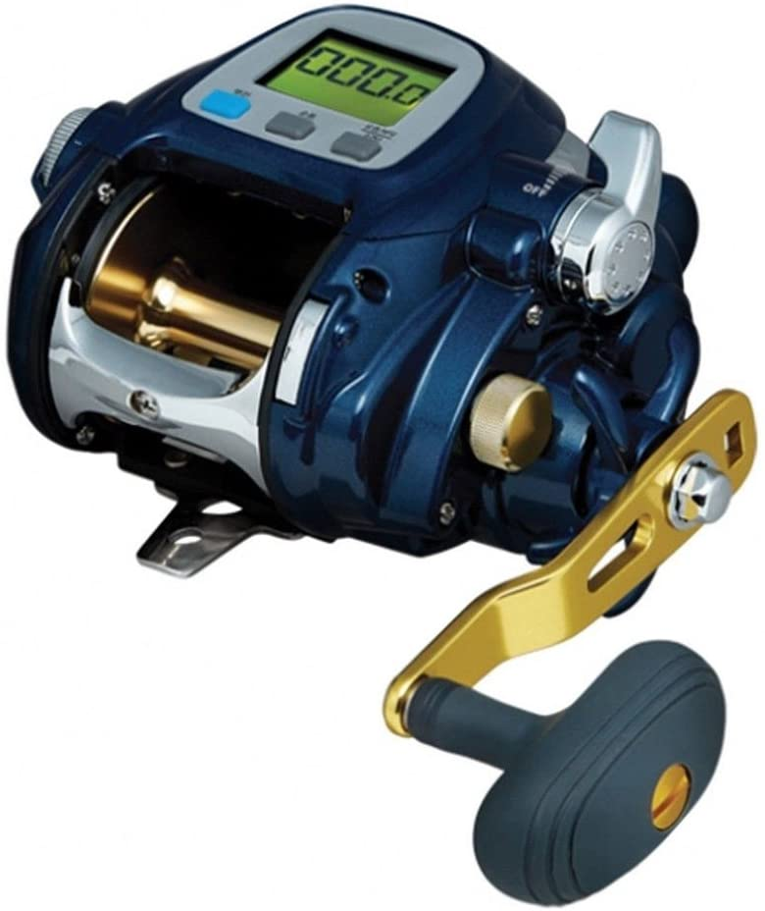

**2. Banax Kaigen 7000CP** - [Banax Kaigen 7000CP Electric Reel Big Game Jigging Fishing Reels EZ Dial -Korean Version-](https://www.amazon.com/dp/B079RY89SY?tag=allfishing086-20&linkCode=ogi&th=1&psc=1&keywords=banax%20kaigen%20electric%20reel)

**Performance** – 2/5

**Durability** – 2/5

**Value for Money** – 5/5

**Overall Score** – 3/5

Bestseller No. 1

If you are looking for a cheaper alternative then have a look at the Banax Kaigen.

It is a Korean made electric fishing reel that comes with a 66lb max drag, gear ratio of 3.5:1, and a motor speed of 170m/minute.

This reel is powered by a 12V source.

While this reel doesn’t have the same pedigree as some of the other brands, it comes at a substantially reduced price point.

My general recommendations for any fishing equipment is not to skimp on quality – the worst scenario you can have is to spend thousands to finally get a gamefish to strike and then experience equipment failure.

This is not a low quality reel, but doesn’t have the same features of other reels.

#### Pros

* This is one of the best value for money alternatives

#### Cons

* Lacks some of the features of the higher end options

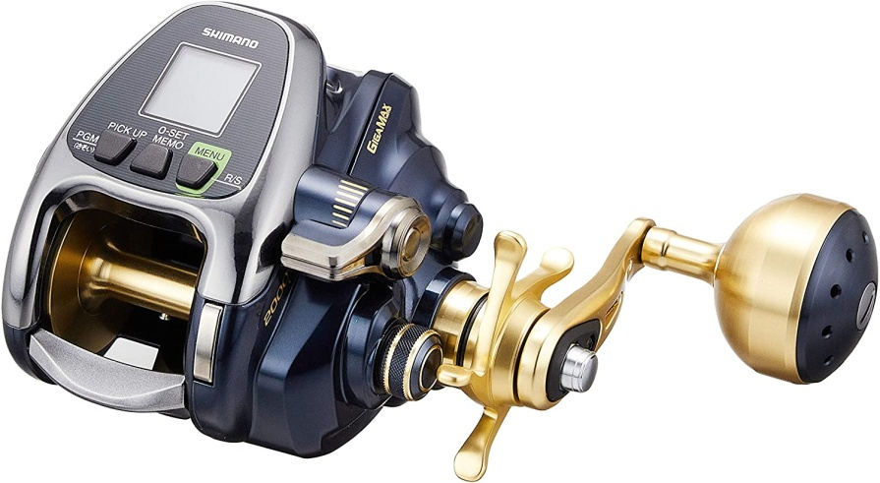

**3. Shimano Beastmaster** - [Shimano Reel Electric Reel 18 Beastmaster 2000](https://www.amazon.com/dp/B079XVCW17?tag=allfishing086-20&linkCode=ogi&th=1&psc=1)

**Performance** – 5/5

**Durability** – 5/5

**Value for Money** – 2/5

**Overall Score** – 4/5

The [Shimano Beastmaster](https://allfishinggears.com/shimano-beastmaster-electric-reel-review/) is the **premier electric fishing reel by Shimano** and contains all of their latest and greatest technologies. It features 10% more winding power than other alternative reels.

It comes with a 3.1:1 gear ratio and 55 lbs of adjustable drag.

It has a brushless motor which reduces noise, improves durability, and reliability. The ball bearings are double shielded anti-rust bearings.

The LCD screen is in English but the manual is often delivered in Japanese.

This is an extremely expensive reel but comes with all of the bells and whistles. You will be happy to have a Shimano Beastmaster when that big gamefish strikes your line.

#### Pros

* Doubled shielded anti-rust ball bearings
* Shimano’s premier electric fishing reel

#### Cons

* Japanese manual can make it difficult to understand

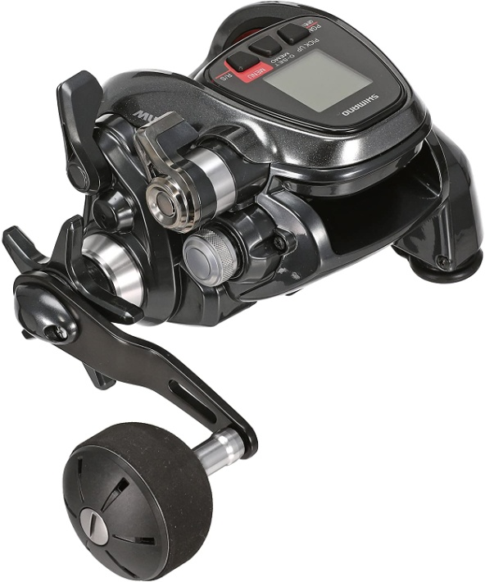

**4. Shimano PLAYS 3000 -** [GOMEXUS Power Cord for Daiwa Tanacom 1000 Seaborg 300J Shimano ForceMaster 2000 Electric Reels Power...](https://www.amazon.com/dp/B07NBNGVNV?tag=allfishing086-20&linkCode=osi&th=1&psc=1&keywords=shimano%20plays%20electric%20reel)

**Performance** – 3/5

**Durability** – 3/5

**Value for Money** – 3/5

**Overall Score** – 3/5

Bestseller No. 1

* 【Suitable for Daiwa Electric Reel】- Tanacom 750 1000, Seaborg 200J-SJ 200J 300MJ 300J 500AT...
* 【Suitable for Shimano Electric Reel】- 18 ForceMaster 600, 16 ForceMaster 1000 2000, 15...
* 【High quality and practicality】- ①The alligator clip is larger than OEM, ensuring good...

Another option by Shimano is the PLAYS 3000. It has recently been **upgraded** to increase the maximum drag and the winding power.

It has a gear ratio of 3.9:1 which is slightly higher than some of the larger electric reels.

It has a winding speed of 190 m/minute and includes a programmable jigging function. The line capacity is 400m of 40lb mono line.

It is powered by a 12V battery, and comes with 5 bearings.

#### Pros

* More affordable Shimano option to the Beastmaster
* Programmable jigging function

#### Cons

* Higher gear ratio than the top end reels

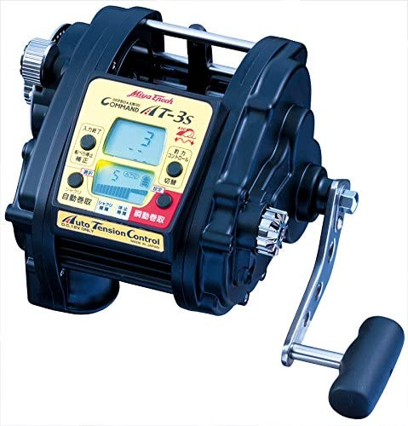

**5. Miya Epoch Command** - [Miya Epoch Command AT-3s DC-12V Big Game Electric Reel](https://www.amazon.com/dp/B008HJUSEY?tag=allfishing086-20&linkCode=ogi&th=1&psc=1)

**Performance** – 3/5

**Durability** – 3/5

**Value for Money** – 3/5

**Overall Score** – 3/5

* Max Rewind Power: 55kg
* Maximum Rewind speed / no load: 150m / minute
* Basic model of light deep sea fishing

One out of left field is the **Miya Epoch Command electric reel**.

This has a winding speed of 150m/minute under no load, and a maximum power of 64 kg.

It is powered by a 12 volt battery. The line capacity of braid is 1200m of 45lb fishing line.

The gear ratio is extremely low of 1.9:1, and comes with 10 ball bearings.

#### Pros

* Japanese made
* Extremely large spool capacity

#### Cons

* Lower gear ratio results in a slightly slower retrieve rate

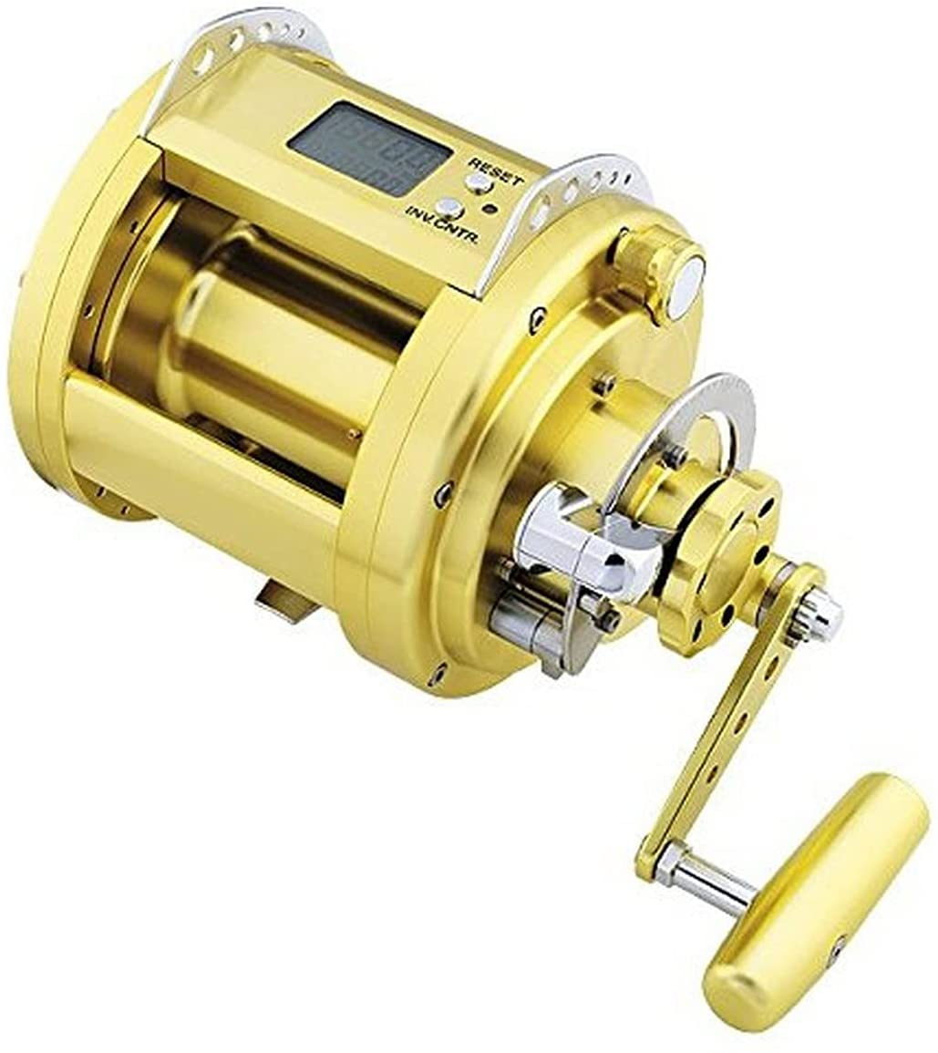

**6. Daiwa 3000 Power-Assist** - [Daiwa Marine Power 3000 - 24 Volt Power Assist Deep Drop Reel (MP3000-24V)](https://www.amazon.com/dp/B014X5WV9U?tag=allfishing086-20&linkCode=ogi&th=1&psc=1)

**Performance** – 4/5

**Durability** – 4/5

**Value for Money** – 4/5

**Overall Score** – 4/5

* Machine-cut aluminum frame, sideplates and spool. Powerful, machined stainless steel gear drive
* 24 Volt System, Momentary winding power = 198 lb, Max winding power = 53lb
* 16 Bearing System ( 1MBB + 1CRBB + 14BB), Magsealed ball bearing (MBB)

Another Daiwa option is the 3000 Power-Assist. This is designed for deep dropping and has a line capacity of 1500 feet of 120lb braided fishing line.

It comes with 16 ball bearings, a powerful machined stainless steel gear drive, a digital readout for line depth, a programmable auto stop feature, and a Power Level for instant control of winding speed.

It has a huge amount of torque with a gear ratio of 1.7:1 and a very high max drag. **This is a serious reel with some serious power.**

#### Pros

* Huge torque and power with a low gear ratio
* Lots of line capacity even with thicker fishing line
* Programmable auto stop feature
* Digital readout of depth

#### Cons

* Slower retrieve rate due to the lower gear ratio

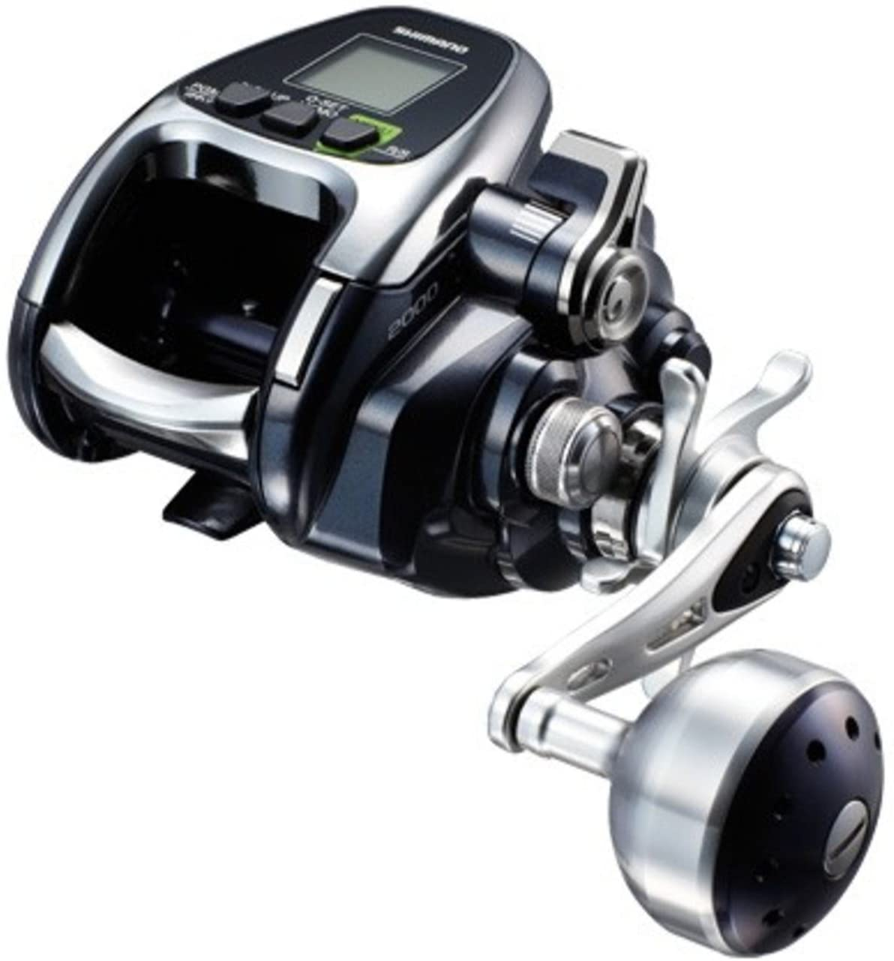

**7. Shimano Forcemaster** - [Shimano Reel Electric Reel 16 fo-sumasuta- 2000](https://www.amazon.com/dp/B01KGI0T42?tag=allfishing086-20&linkCode=ogi&th=1&psc=1)

**Performance** – 5/5

**Durability** – 5/5

**Value for Money** – 2/5

**Overall Score** – 4/5

The [Shimano Forcemaster](https://allfishinggears.com/shimano-forcemaster/) is one of the premier electric reels and it costs a substantial amount. It has a 135 m/minute maximum winding speed.

It has a 3.1:1 gear ratio and has some serious torque to catch big gamefish like sailfish.

It has a sleek and stylish design that is suitable for kite fishing, deep bottom fishing, or billfish fishing.

It has a jigging mode (called invitation mode) to help attract fishing even at extreme depths. This is either a 3 step pattern or an original pattern.

#### Pros

* Good combination of torque and power
* Automated jigging function

#### Cons

* Slower retrieve rate than the other options
* Extremely expensive and at the lower end of the value for money spectrum

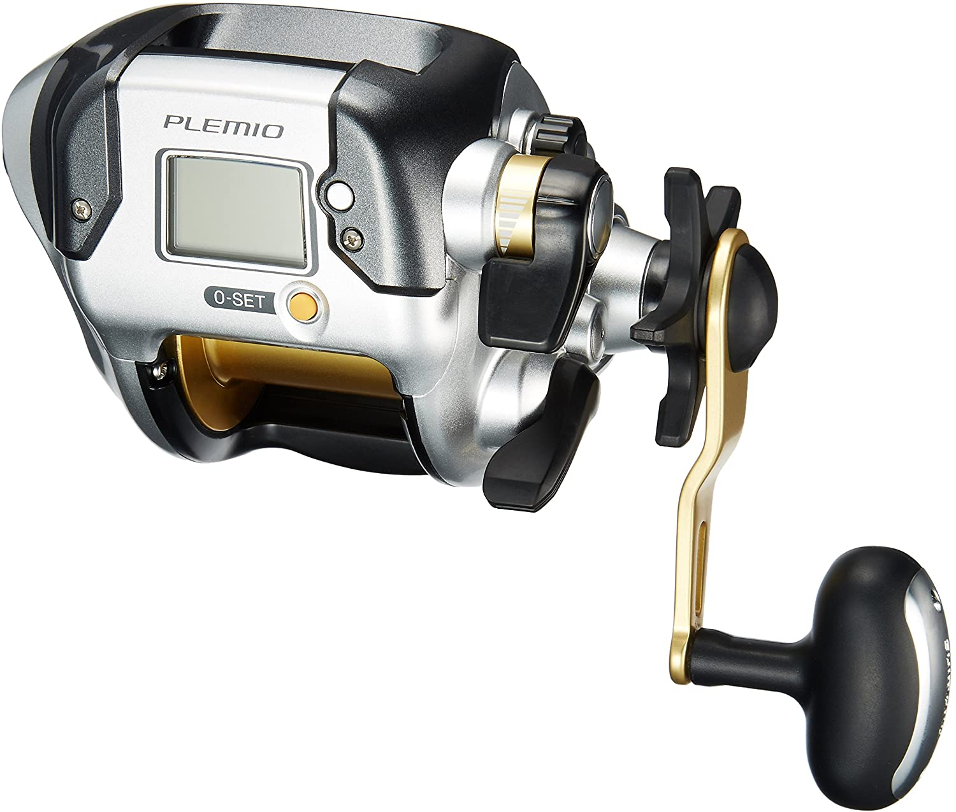

**8. Shimano Plemio** - [Shimano PLEMIO 3000 Big Game [Japan Import]](https://www.amazon.com/dp/B014U5ID6S?tag=allfishing086-20&linkCode=ogi&th=1&psc=1&keywords=shimano%20plemio%20electric%20reel)

**Performance** – 3/5

**Durability** – 4/5

**Value for Money** – 4/5

**Overall Score** – 4/5

Bestseller No. 1

* Gear Ratio：3.6
* S A-RB/Roller Bearing：1/0
* Weight：625g

One of the more affordable Sheminao electric reels is the Plemio. This comes with a 3.6:1 gear ratio, and shielded anti rust bearings.

It is powered by a 12V battery.

The Plemio is simple – just press one button and let the motor do the rest of the work. It is a simple and easy way to do deep sea fishing.

Some of the features include Super Slow retrieve, automatic retrieve, and a Rakuraku mode that will adjust the motor speed based on the load.

#### Pros

* Extremely simple functionality with super slow retrieve and load adjusted retrieve

#### Cons

* More affordable but lacks some of the high end functions

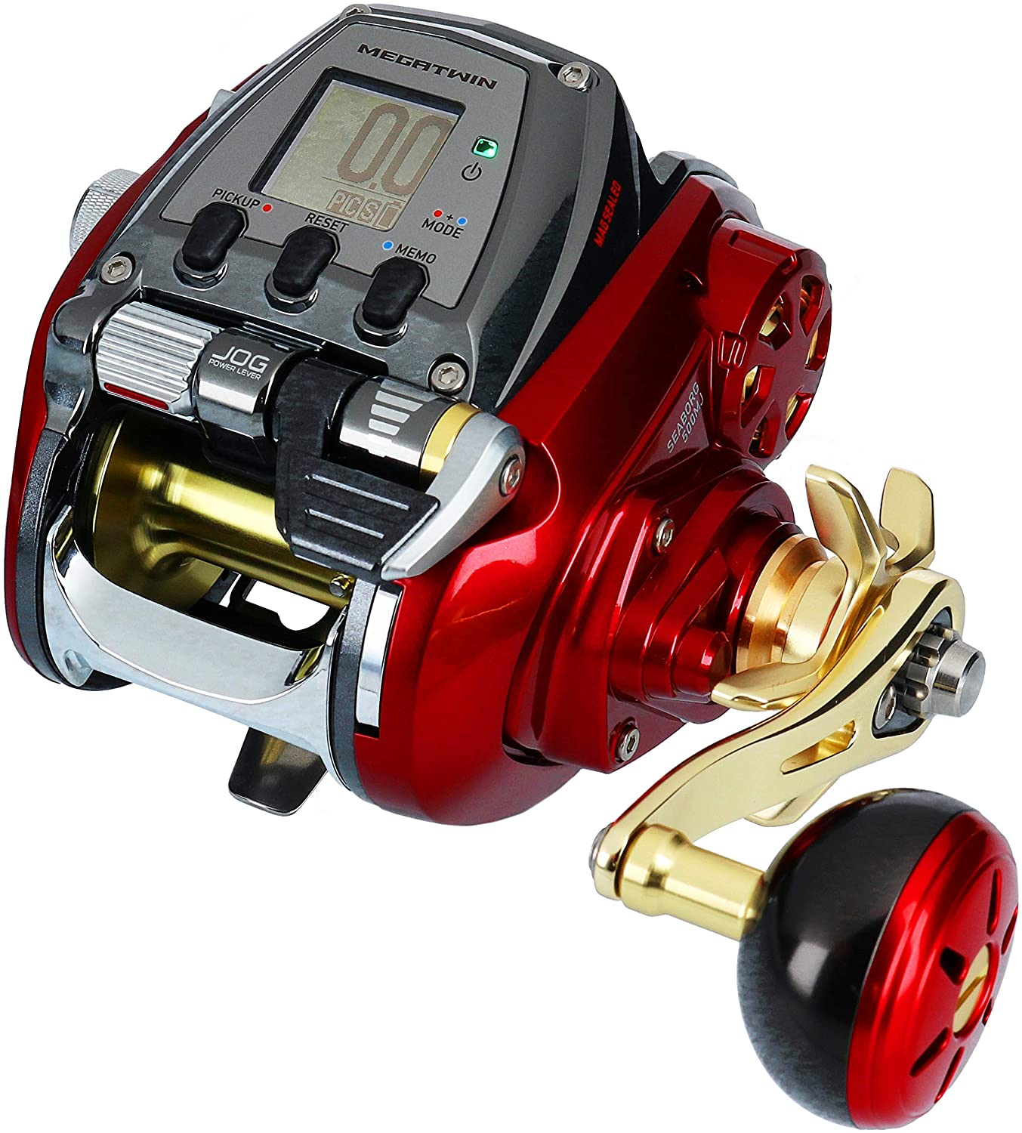

**9. Daiwa 500 MJ Seaborg** - [Daiwa 19 Seaborg 500MJ (Electric Reel)](https://www.amazon.com/dp/B07MZXZZXK?tag=allfishing086-20&linkCode=ogi&th=1&psc=1)

**Performance** – 5/5

**Durability** – 5/5

**Value for Money** – 1/5

**Overall Score** – 3/5

Another model by Daiwa is the 500 MJ Seaborg. First things first – this reel is absolutely gorgeous. The red body with gold trim looks brilliant.

It has a dot screen display which can sometimes be easier to read due to sun glare.

It comes with 22 ball bearings, line counter, and depth memory.

It also comes with improved drag grease that has a low viscosity at rest and becomes more viscous after the drag starts up – this reduces the initial drag inertia.

#### Pros

* Beautiful aesthetic design
* Easy to read dot screen display

#### Cons

* Very expensive considering its functionality compared to the alternatives

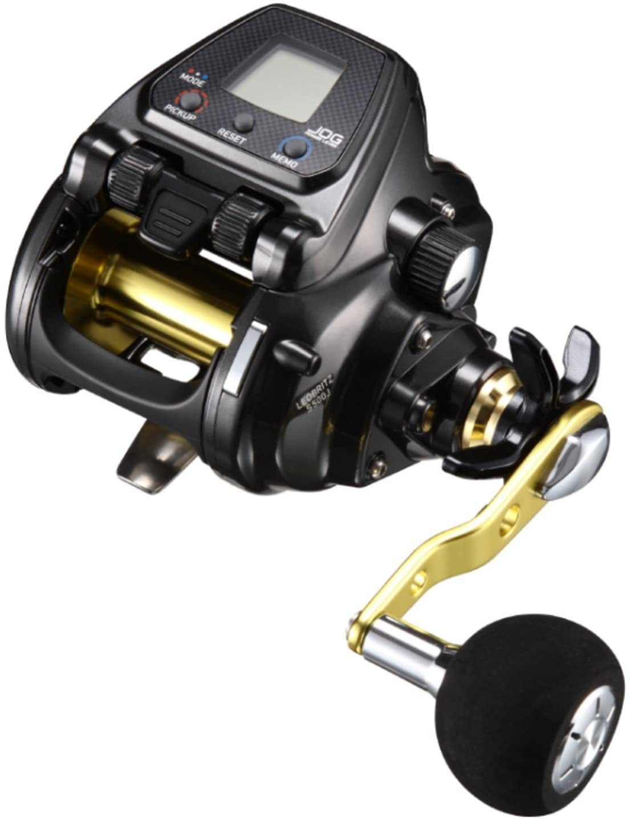

**10. Daiwa 500 Leobritz** - [Leobritz Daiwa 2017 S500J Electric Reel](https://www.amazon.com/dp/B076DXP571?tag=allfishing086-20&linkCode=ogi&th=1&psc=1&keywords=daiwa%20leobritz%20electric%20reel)

**Performance** – 3/5

**Durability** – 3/5

**Value for Money** – 4/5

**Overall Score** – 3/5

Bestseller No. 1

Finally is the Daiwa 500 Leobritz. This is a much smaller reel than some of the others and comes at a lower cost.

It as a gear ratio of 3.7:1, but only a max drag of 15 kg. **This is not suitable for big game fishing.**

It is Made in Japan with a line capacity of 500m of 40 lb fishing line.

It comes with 7+1 ball bearings.

#### Pros

* Much more affordable
* Better suited for anglers with physical difficulties
* 500m line capacity is good for deep reefs and dropping baits to the sea floor

#### Cons

* Smaller reel than the alternative options so make sure you target the right species
* Not suitable for big game fishing

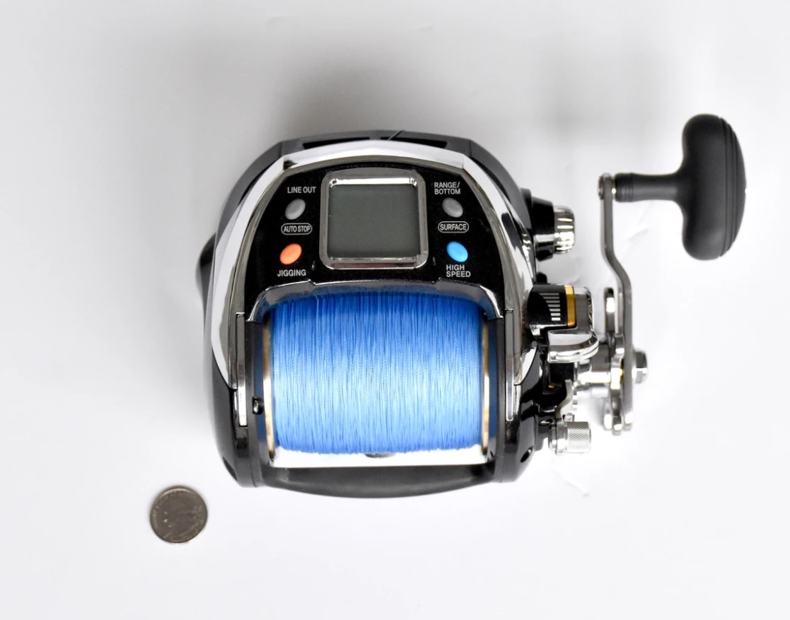

**2. Banax Kaigen 1000** – WEBSITE: https://www.deepdropper.com/collections/banax-electric-reels

**Performance** – /5

**Durability** – /5

**Value for Money** – /5

**Overall Score** – /5

**FEATURES**

• Black anodized aluminium diecasting frame .• Aluminium forged spool. • Smooth carbon fiber drag washers.

• Washable design. • Jigging function .• Accurate adjustable LCD unit to set the depth, with memory backup

• Motor overload control. • 2 Over sized ball bearings. • Level wind. • English Instruction manual.

• 9ft (2.76m) 12v power cord.

**SPECIFICATIONS**

• High torque 12 volt DC motor. • Gear Ratio: 2.8:1 • Weight: 1630g • Bearings: 2 B/B • Instant maximum winding power: 90 Lbs • Max. drag force: 45 Lbs • Max. speed 160m/min • Line capacity: (Braid) • 1000M 65 Lb Braid, 800M 80Lb Braid, 600M 100Lb Braid

It has a gear ratio of 2.8.1, with a max drag of 45 Lbs.

It is Made in Japan with a line capacity of 1000M of 65 lb fishing line.

It comes with 2 over sized ball bearings.

## Specification Comparison

|  |  |  |  |  |  |  |  |
| --- | --- | --- | --- | --- | --- | --- | --- |
| **Electric Reels** | **Score** | **Ball Bearings** | **Max Drag** | **Gear Ratio** | **Weight** | **Retrieve Rate** | **Price Range** |
| 1. Daiwa Tanacom | 5/5 | 4 | 44 lb | 2.3:1 | 52 oz | 130m/minute | **$$ $649.99 Tackle Direct** |
| 2. Banax Kaigen | 3/5 | 5 | 66 lb | 3.5:1 | 31 oz | 170m/minute | **$ $424.70 Amazon** |
| 3. Shimano Beastmaster | 4/5 | 14 | 55 lb | 3.1:1 | 52 oz | 180m/minute | **$$$ $950.00 Amazon** |
| 4. Shimano PLAYS 3000 | 3/5 | 5 | 33 lb | 3.9:1 | 24 oz | 190m/minute | **$$ $401.99 EBAY** |
| 5. Miya Epoch Comand | 3/5 | 10 | 62 lb | 1.9:1 | 64 oz | 150m/minute | **$$$ $1004.80 Amazon** |
| 6. Daiwa 3000 | 4/5 | 16 | 200 lb | 1.7:1 | 196 oz | 80m/minute | **$$$$ $3499.99 Melton’s** |
| 7. Shimano Forcemaster | 4/5 | 3 | 55 lb | 3.1:1 | 54 oz | 135m/minute | **$$$ $615.09 Amazon** |
| 8. Shimano Plemio | 4/5 | 1 | 22 lb | 3.6:1 | 22 oz | 175 m/minute | **$ $339.70 Amazon** |
| 9. Daiwa 500MJ Seaborg | 3/5 | 22 | 50 lb | 3.6:1 | 34 oz | 175 m/minute | **$$$ $1318.47 Amazon** |
| 10. Daiwa 500 Leobritz | 3/5 | 8 | 33 lb | 3.7:1 | 28 oz | 140m/minute | **$$ $421.56 Amazon** |
| 11. Banax Kaigen 1000 | ?/5 | 2 | 45 lb | 2.8:1 | 58 oz | 160m/minute | **$$ $649.00 Deepdropper** |

## Frequently Asked Questions

### What maintenance does an electric fishing reel need?

This all depends on the model you select – read through the manual carefully to make sure you are doing everything required to maintain your new reel for the long term. This will certainly include flushing your reel with freshwater to remove any salt and sand from the gearing.

### What power source does an electric reel use?

There are generally two power sources for an electric reel – either a 12V car battery or hooked directly into the battery on your boat. Read the product description carefully to see what the power source is for individual electric reels.

### Can you use an electric reel manually?

Absolutely – most electric fishing reels come with a handle and you can fishing manually with them by cranking the handle.

### Do you need a fish descender with deep water fishing?

Yes, we always recommend having a [fish descender](https://allfishinggears.com/when-to-use-a-fish-descender-2021/) with you when fishing deep water so that you can ensure your released fish have the highest likelihood of survival.

## ****Conclusion****

The first step is to [decide whether you need an electric fishing reel or not](https://fishanywhere.com/blog/electric-fishing-reels-when-are-they-used/).

Electric fishing reels are sometimes a necessary option over non-powered reels. They come at a range of cost options same as standard reels, but offer several advanced features that make your fishing experience fun and possible if fishing really deep waters that require heavy weights and a lot of physical work. Although it is not a common practice to use an electric fishing reel, with the powered feature, you’ll be able to catch more fish with little to no effort. Powered reels have never been a common thing because they were so expensive. With global economies that has all changed and now they are more affordable for the average fisherman.

Powered reels can also work both ways! In case you are out of power, you can use it as a regular reel or get the fish up to a reasonable depth to the boat and the fight it manually. They are quite durable and don’t require much care and maintenance.

But if you’re a beginner and have no fishing experience, start by purchasing a **low-budget electric reel**. You can use it for gaining some experience and learning how it feels and functions. Once you get the proper control over it, you can switch to a high-end and better quality electric fishing reel.

If you are looking for more information on electric fishing reels then there are some other guides available online.

Happy fishing!